|  |  |
| --- | --- |
| LIFE logo | **HOLY CROSS COLLEGE**  **SEMESTER 1, 2020**  **Question/Answer Booklet** |

Please place your student identification label in this box

12 PHYSICS

Student Name ___________________________________

Student’s Teacher __________________________________________

#### Time allowed for this paper

Reading time before commencing work: 10 minutes

Working time for paper: 3 hours

**Materials required/recommended for this paper**

**To be provided by the supervisor**

This Question/Answer Booklet

Multiple-choice Answer Sheet

Data Sheet

***To be provided by the candidate***

Standard items: pens, pencils, eraser, correction fluid, ruler, highlighters

Special items: non-programmable calculators satisfying the conditions set by the School Curriculum and Standards Authority for this course

**Important note to candidates**

No other items may be taken into the examination room. It is **your** responsibility to ensure that you do not have any unauthorised notes or other items of a non‑personal nature in the examination room. If you have any unauthorised material with you, hand it to the supervisor **before** reading any further.

**Structure of this paper**

|  |  |  |  |  |  |
| --- | --- | --- | --- | --- | --- |
| Section | Number of questions available | Number of questions to be answered | Suggested working time  (minutes) | Marks available | Percentage of exam |
| Section One:  Short Answers | 11 | 11 | 50 | 55 | 31 |
| Section Two:  Problem-solving | 6 | 6 | 90 | 85 | 48 |
| Section Three:  Comprehension | 2 | 2 | 40 | 38 | 21 |
|  | | | | 178 | 100 |

**Instructions to candidates**

1. The rules for the conduct of examinations at Holy Cross College are detailed in the College Examination Policy*.* Sitting this examination implies that you agree to abide by these rules.

2. Write your answers in this Question/Answer Booklet.

3. Working or reasoning should be clearly shown when calculating or estimating answers.

4. You must be careful to confine your responses to the specific questions asked and to follow any instructions that are specific to a particular question.

5. Spare pages are included at the end of this booklet. They can be used for planning your

responses and/or as additional space if required to continue an answer.

• Planning: If you use the spare pages for planning, indicate this clearly at the top of the

page.

• Continuing an answer: If you need to use the space to continue an answer, indicate in

the original answer space where the answer is continued, i.e. give the page number.

Fill in the number of the question(s) that you are continuing to answer at the top of the

page.

6. Answers to questions involving calculations should be ***evaluated and given in decimal***

***form*.** It is suggested that you quote all answers to ***three significant figures***, with the

exception of questions for which estimates are required. Despite an incorrect final result,

credit may be obtained for method and working, providing these are ***clearly and legibly set***

***out***.

7. Questions containing the instruction *"****estimate****"* may give insufficient numerical data for their

solution. Students should provide appropriate figures to enable an approximate solution to

be obtained. Give final answers to a maximum of ***two significant figures*** and include appropriate units where applicable.

8. Note that when an answer is a vector quantity, it must be given with magnitude and direction.

9. In all calculations, units must be consistent throughout your working.

**Section One: Short response 31% (55 Marks)**

This section has **11** questions. Answer **all** questions.

Suggested working time: 50 minutes.

**Question 1 (4 marks)**

The diagram below shows two planets ‘X’ and ‘Y’ which have masses of ‘m’ and ‘5m’ respectively.

[The measurements described in this question for Planet ‘X’ and Planet ‘Y’ are made independently of each other]

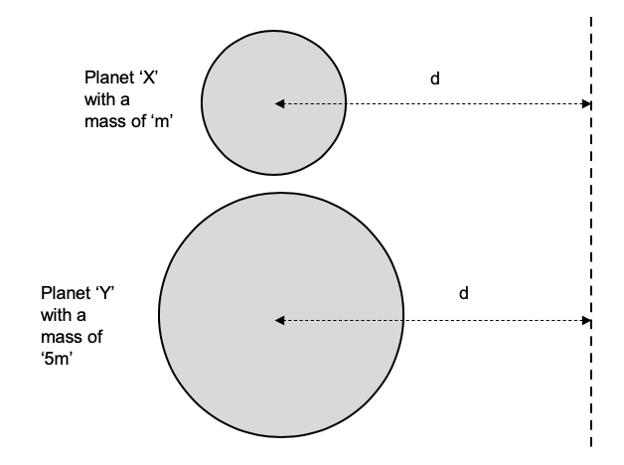

The gravitational field strength is measured at a distance ‘d’ from each planet’s centre of mass

(as shown). The gravitational field strength due to Planet X at distance ‘d’ is measured to be

2.50 ms-2.

Calculate the gravitational field strength at distance ‘d’ from Planet Y.

**Question 2 (4 marks)**

A bird is able turn in a circular path of radius ***r*** at a particular speed ***v*** by banking its wings at an angle ***θ*** to the horizontal towards the centre of this path. See below.

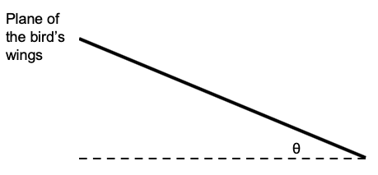

Explain why the angle of banking ***θ*** of the bird needs to increase if the radius of its circular path decreases while maintaining the same air speed ***v***. Include an appropriate mathematical expression and a vector diagram to aid your answer. You can assume that any lift forces are perpendicular to the plane of the bird’s wings.

**Question 3 (4 marks)**

***Estimate*** the minimum horizontal force required to tip over a fully-filled 1 litre Coke bottle with a base width of about 7 cm and a height of about 30 cm. Clearly state any assumptions you make while answering this question. Draw any appropriate forces and distances on the diagram.

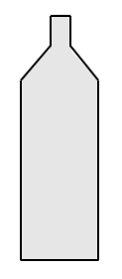

**Question 4 (4 marks)**

An eagle of mass 55.0 kg swoops down on its prey. It follows a circular arc of radius 87.0 m and is travelling at a top speed of 27.0 ms-1.

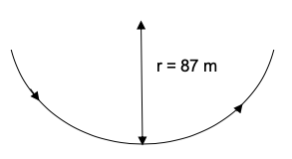

(a) Ignoring air resistance, calculate the maximum force experienced by the eagle’s wings as it catches its prey. (3 marks)

(b) Clearly state the point at which this maximum force occurs. (1 mark)

**Question 5 (5 marks)**

A projectile is fired upwards at an angle to the horizontal and lands at the same height from which it is launched. **Note:** ***Take up as positive direction.***

(a) Which pair of graphs best describes:

(i) the vertical component of the projectile’s velocity (v)

(ii) the projectile’s acceleration (a)

as a function of its flight time (t). (2 marks)

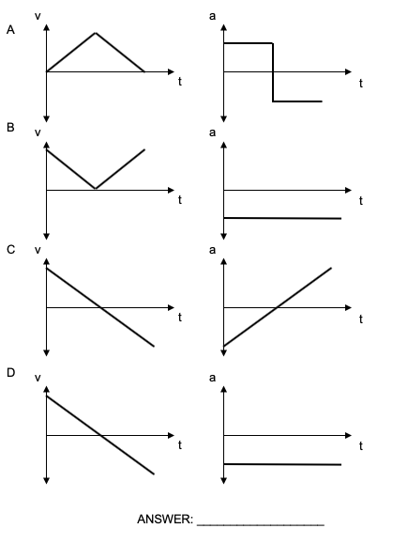

(b) On the axes below, sketch a graph for the vertical component of the projectile’s velocity (***v***) as a function of its flight time (***t***) when air resistance is taken into account. No values need to be written - but relative sizes of quantities must be shown. (3 marks)

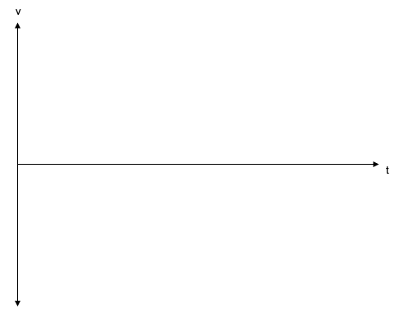

**Question 6 (8 marks)**

A pair of parallel metal plates, placed in a vacuum, are separated by a distance 4.00 mm and have a potential difference of 1.20 kV applied between them.

(a) Calculate the magnitude of the electric field between the two plates. (2 marks)

(b) Calculate the magnitude of the electrostatic force acting on an electron placed between the plates. (2 marks)

A beam of electrons is fired between the plates at a speed of 4.50 x 106 ms-1 in the direction shown.

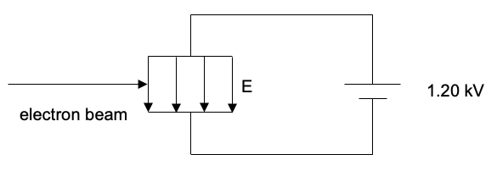

A magnetic field is applied to the electron beam sufficient to allow the electron beam to pass between the plates without deviating.

(c) On the diagram, indicate the direction of this magnetic field. (1 mark)

(d) Hence, calculate the magnitude of the magnetic field required. (3 marks)

**Question 7 (7 marks)**

A motorbike and rider have a combined mass 325 kg. They are travelling on a road banked at an angle of 32.0° to the horizontal. A frictional force of 6.00 x 102 N acts down the slope.

(a) Draw a free-body diagram showing the forces acting on the motorbike and rider.

(3 marks)

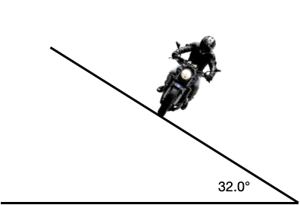

(b) Calculate the magnitude of the nett force experienced by the motorbike. (4 marks)

**Question 8 (7 marks)**

The diagram below shows a pulley system designed to raise a mass. At the instant shown, the system can be considered to be in equilibrium.

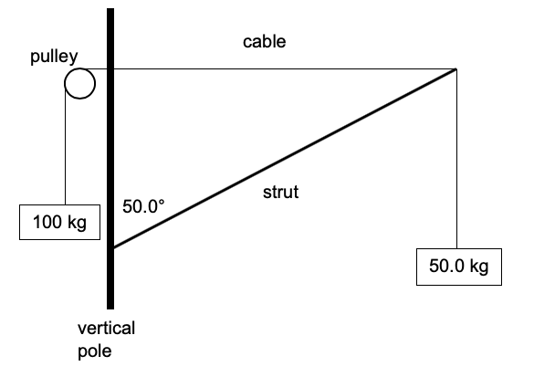

The strut is uniform and is 2.00m in length. It is attached to a vertical pole by a hinge and forms an angle of 50.0° with the vertical pole as shown. A 50.0 kg mass is suspended from the end of the strut as shown. The strut is held in place by a cable attached to its end; the cable runs over the pulley and has a 1.00 x 102 kg mass attached to it as shown in the diagram, which provides a tension force. The length of cable between the pulley and the end of the strut is horizontal.

(a) Calculate the mass of the strut. (4 marks)

(b) Determine the reaction force exerted by the hinge onto the strut. (3 marks)

**Question 9 (3 marks)**

Two positively-charged point charges of magnitude ***q1*** and ***q2*** (in Coulombs) are separated by a distance **d** and experience an electrostatic force **F**.

The charge sizes are changed to ***2q1*** and ***3q2*** and the distance is reduced to ***0.50d***. Determine an expression for the electrostatic force between these two charges in terms of ***F***.

**Question 10 (4 marks)**

(a) Calculate the magnetic field strength at a distance of 20.0 cm from a long straight conductor carrying a current of 0.550 A. The experiment is performed in air. (2 marks)

(b) The magnetic constant ***μo*** is also known as “the magnetic permeability of free space”. The magnetic permeability of water is slightly lower than the value for free space. If the experiment in part (a) was conducted in water, explain how that would change the result calculated in air.

(2 marks)

**Question 11 (5 marks)**

A proton with a speed of 1.70 x 107 ms-1 enters a mass spectrometer that has a magnetic field of 3.00 T. It is bent into a circular arc by this magnetic field and crashes into the detector as shown below. In the questions that follow, ignore relativistic effects.

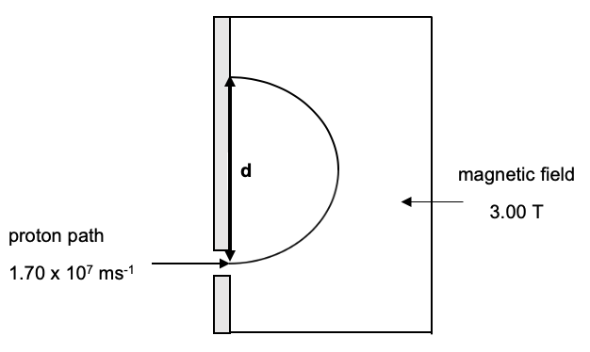

(a) On the diagram, in the region labelled ‘magnetic field’, draw the direction of the field that would bend the protons into the path shown. (1 mark)

(b) Calculate the distance ***d*** shown on the diagram. Show your working. (4 marks)

**Section Two: Problem-solving 48% (85 Marks)**

This section has **six (6)** questions. Answer **all** questions. Write your answers in the spaces provided.

Suggested working time: 90 minutes.

**Question 12 (14 marks)**

Electric motors are used to do a variety of tasks. One common use is to lift weights (e.g. in a crane or a lift). The input into the motor is electrical energy and the output is the work done in lifting the mass (i.e. a gain in gravitational potential energy (∆Ep). A diagram outlining this system is shown below.

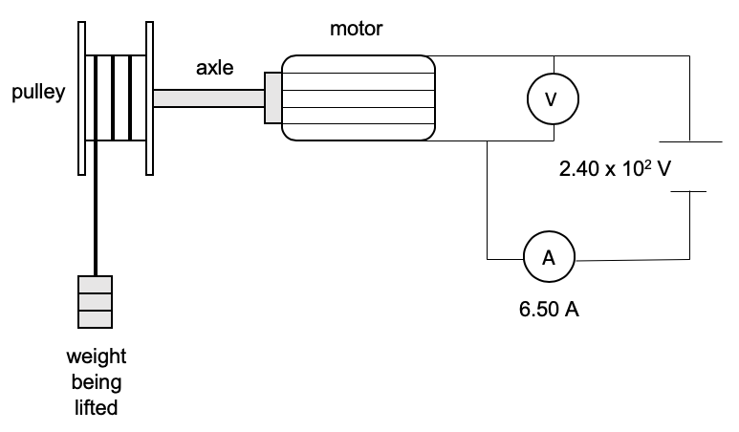

The DC motor operates at a voltage of 2.40 x 102 V and draws a current of 6.50 A. It is able to lift a mass of 30.0 kg through a vertical height of 3.50 m in 1.05 s.

(a) Calculate the gain in gravitational potential energy (∆Ep) experienced by the mass and hence, the rate at which the DC motor does work on the mass. (3 marks)

(b) Calculate the electric power generated by the DC motor and, hence, the percentage efficiency of the electric motor.

[If you were unable to calculate an answer for the rate at which the motor does work on the mass in part (a), use 1.00 x 103 W] (3 marks)

The pulley has a diameter of 65.0 cm. The DC motor consists of a rectangular 200 turn coil (ABCD) that has the dimensions shown in the diagram below. The coil lies in a magnetic field of strength ‘B’ Tesla (see diagram).

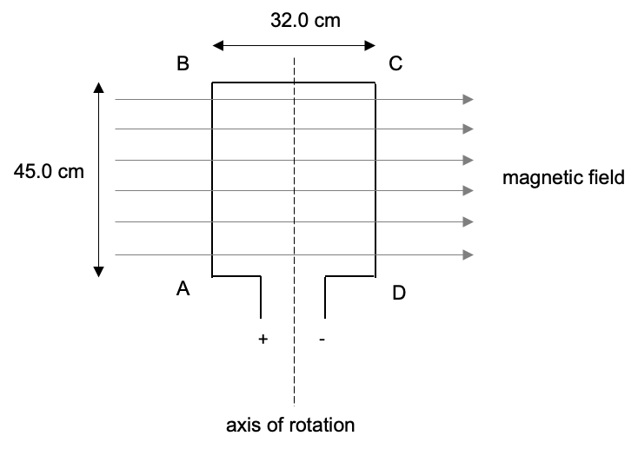

(c) Given the polarity of the current flowing in the coil, state the direction of the magnetic force experienced by:

(i) side AB

(ii) side BC. (2 marks)

The DC motor raises the 30.0 kg mass at a constant velocity.

(d) Given the dimensions of the pulley, calculate the maximum torque produced by the DC motor.

(3 marks)

(e) Hence, calculate the size of the magnetic field ‘B’. [Hint if you were unable to calculate an answer for part (d), use 96.0 Nm] (3 marks)

**Question 13** **(13 marks)**

A soccer player is shooting at a goal from directly in front of it. The player is 15.0 m from the goal line and kicks the ball with a launch angle of 30.0° to make sure the ball gets over a ‘wall’ set up by the opposition. The diagram below illustrates this situation. The height of the goal (i.e. the crossbar above the ground) is 2.44 m.

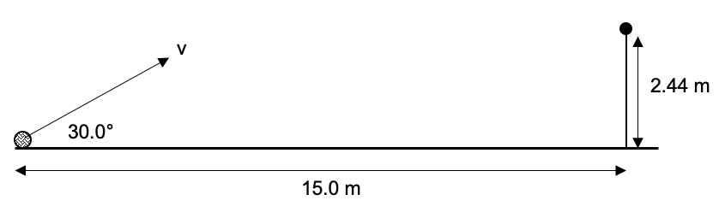

The player is trying to launch the ball with a velocity ***v*** that allows it pass under the crossbar. For parts (a), (b) and (c), ***IGNORE*** the effects of air resistance and the width of the ball.

(a) Write down expressions for the horizontal (vh) and vertical (vv) components of the launch velocity in terms of ***v*** and ***θ***. Show clearly how you obtained these with a vector diagram.

(4 marks)

vh = _________________ vv = _________________

(b) Using horizontal components, show that the mathematical expression for the time taken for the ball to reach the goal line is:

$$\text{t = }\frac{\text{17.3}}{\text{v}}$$

(3 marks)

(c) Using the expression derived in part (b), data from the vertical plane and an appropriate motion formula, calculate the maximum launch velocity ***v*** that allows the ball to pass under the crossbar. (4 marks)

(d) If air resistance is taken into account, state how the following would have to change for a successful shot. (2 marks)

(i) Launch velocity ***v*** if launch angle ***θ*** remains at 30°.

(ii) Launch angle ***θ*** if the launch velocity ***v*** remains at the answer calculated in part (c).

**Question 14** **(14 marks)**

The diagram below shows the side-on view of a single drawer in a chest of drawers. The drawer is in an extended, open position and a book has been placed inside it as shown. The drawer is held in place by two identical pieces of wood acting as brackets above and below it. The drawer slides in and out between these two brackets when it is pushed and pulled by its handle. Two points, ***X*** and ***Y***, are labelled on each bracket as shown.

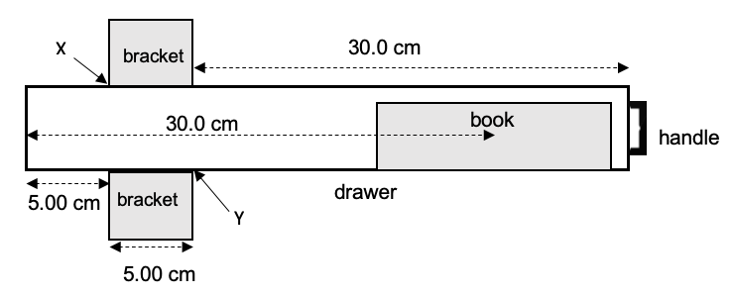

Both the drawer and the book can be considered to be uniform and have masses of 1.20 kg and 0.850 kg respectively. The distance from the left-hand edge of the drawer to the centre of mass of the book is measured to be 30.0 cm (as shown). The mass of the handle is insignificant and can be ignored.

The other significant dimensions in this situation are shown.

In this extended position, the drawer is in equilibrium and stationary. It can also be considered to be horizontal and pivots about the lower bracket at point ***Y***.

(a) On the diagram above, draw a labelled free-body diagram showing all the forces acting on the drawer. Make sure you include ***Fx*** and ***Fy*** - the forces acting at points ***X*** and ***Y***.

(4 marks)

(b) Given that the drawer is in a state of mechanical equilibrium, calculate:

(i) the magnitude of the force acting at ***X***. (3 marks)

(ii) the magnitude of the force acting at ***Y***.

[If you were unable to calculate an answer for part (b) (i), use a value of 58.0 N].

(3 marks)

(c) The drawer is slowly pushed back into its unextended position within the chest of drawers by being pushed towards the left by the handle. Describe how the magnitude of the forces at ***X*** and ***Y*** will change as this drawer is pushed back to its unextended position. Explain your answer. (4 marks)

**Question 15 (14 marks)**

NASA astronauts need to train to operate in the weightless conditions they experience when they are in orbit around the Earth. A specially-designed aeroplane called G-FORCE-ONE (known as a ZERO-G plane) is employed to do this training.

(a) Explain why astronauts in orbit experience weightlessness. As part of your response, answer this question: ***Are the astronauts actually weightless?*** (3 marks)

In order for the passengers on G-FORCE-ONE to feel weightless, the aircraft must climb at a steep angle (45° nose high), level off and then dive, creating a parabolic path. In the diagram below, the arrow represents the direction of flight of the ZERO-G plane.

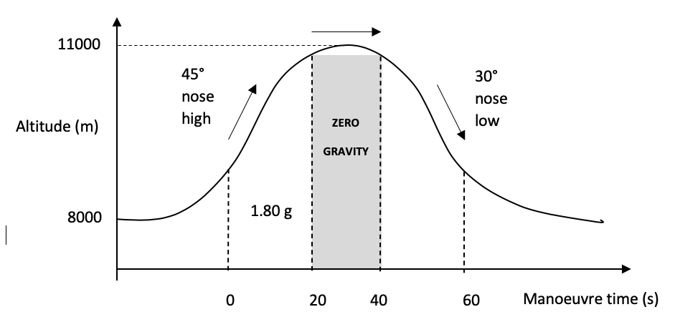

As the ZERO-G plane climbs to the peak of its arc, the pilot orients it at a 45° angle upwards (as shown).

(b) During the climb, the plane and its passengers experience a nett acceleration equal to 1.80 times the strength of gravity alone; i.e. the passengers’ apparent weight becomes nearly twice as much as their true weight. Calculate the plane’s acceleration vertically upwards that creates the 1.80 g acceleration on the passengers. (4 marks)

(c) Explain how apparent weightlessness (‘zero gravity’) is achieved at the top of the parabolic arc. (3 marks)

(d) If the radius of the arc at the top of the parabolic path is equal to 5.00 x 102 m, calculate the speed that the plane must be travelling at to achieve ‘weightlessness’. Assume that the plane’s motion is circular at this point. (4 marks)

**Question 16 (15 marks)**

During a Physics experiment investigating horizontal circular motion, a student is swinging a

0.150 kg mass in a horizontal circle of radius 23.0 cm. The mass is attached to a string that is

45.0 cm in length.

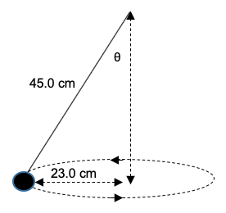

(a) Draw a ***vector diagram*** showing the forces acting on the mass and the nett force that results.

(3 marks)

(b) Use the dimensions of the string and the radius of the path to perform a calculation to find the value of ***θ***. (2 marks)

(c) Hence, calculate the tension in the string. [If you could not calculate a value for ***θ***, use 30.0°]

(4 marks)

(d) Calculate the period (T) of revolution for the mass. (6 marks)

**Question 17 (15 marks)**

A small charged object of mass 0.500 mg is suspended from a 25.0 cm long piece of string made of insulating material. The charge on the object is 25.0 nC.

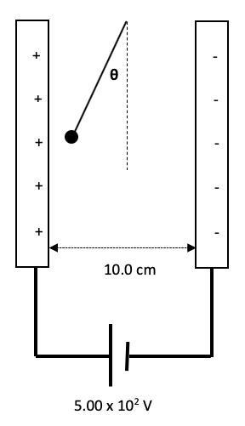

(a) On the diagram above, draw a free-body diagram showing all forces acting on the object.

(3 marks)

(b) Is the object positively or negatively charged? Explain your choice (2 marks)

(c) Calculate the electrostatic force acting on the charged object. (4 marks)

(d) Calculate the size of the angle ***θ***. Show all working. [If you could not calculate an answer for part (c), use FE = 1.4 x 10-4 N]. (3 marks)

(e) Determine the tension force in the string. (3 marks)

**Section Three: Comprehension 21% (37 Marks)**

This section has two (2) questions. Write your answers in the spaces provided.

Spare pages are included at the end of this booklet. They can be used for planning your responses and/or as additional space if required to continue an answer.

Suggested working time: 40 minutes.

**Question 18 (21 marks)**

**EVIDENCE FOR DARK MATTER**

By examining the light from stars, astronomers are able to measure the rotational (orbital) speeds of stars in our own Milky Way. The distance of each star to the galactic centre around which all the rotations occur (i.e. their orbital radii) can also be determined by various means.

If the mass of the Milky Way galaxy was equal to the ‘normal’ visible matter in the stars seen by astronomers, then the rotational speeds of the stars should vary as predicted by ‘Keplerian Motion’. Newton’s Laws can be used to predict the stars’ speeds from their orbital radius.

However, when the orbital speeds of stars in the Milky Way galaxy are measured, we find that no matter the orbital radius, these are virtually constant - they do not decrease as the distance from the galactic centre increases.

One explanation for this phenomenon is that there are huge amounts of unseen ‘dark’ matter in outer parts of the galaxy causing the stars to orbit more quickly.

The table below contains data for six (6) stars in the Milky Way galaxy - including our own Sun. The data shows orbital radius (***r***); predicted orbital speed (***vp***); the square of the predicted orbital speed (***vp2***); and the inverse of the orbital radius (***1/r***). Some values are missing in the last two (2) columns.

|  |  |  |  |  |
| --- | --- | --- | --- | --- |
| **Star** | **Orbital Radius (r)**  **(x 1020 m)** | **Predicted Orbital Speed (vp)**  **(x 104 ms-1)** | **Square of Predicted Orbital Speed (vp2)**  **(x 109 m2s-2)** | **Inverse of Orbital Radius (1/r)**  **(x 10-21 m-1)** |
| **1** | **0.473** | **25.5** | **65.0** | **21.1** |
| **2** | **1.42** | **14.7** | **21.6** | **7.04** |
| **SUN** | **2.65** | **10.8** |  | **3.77** |
| **3** | **4.54** | **8.23** | **6.77** |  |
| **4** | **6.34** | **6.97** | **4.86** | **1.58** |
| **5** | **8.57** | **6.01** | **3.61** | **1.17** |

(a) Complete the table by calculating the missing values in the last two columns. (2 marks)

(b) By combining concepts of gravitational force and centripetal force, an expression for orbital speed can be derived. This expression is:

$$v^{2}=\frac{Gm}{r}$$

In the space below, show how the expression above is derived. (3 marks)

(c) On the grid on the next page, plot a graph of ‘Square of Predicted Orbital Speed (***vp2***)’ versus ‘Inverse of Orbital Radius (***1/r***)’. Place ‘Inverse of Orbital Radius (1/r)’ on the horizontal axis. Draw a line of best fit for your data. (4 marks)

(d) Calculate the gradient of your line of best fit. Include appropriate units. (4 marks)

(e) Use the expression derived in part (b) and the gradient from part (d) to calculate a predicted value for the mass of the galaxy. (4 marks)



As stated in the article, when the ***actual*** orbital speeds of stars in the Milky Way galaxy are measured, we find that no matter the orbital radius, these are virtually constant - they do not decrease as the distance from the galactic centre increases.

(f) This suggests when the ‘Square of the Actual Orbital Speeds (***vA2***)' is plotted against the ‘Inverse of Orbital Radius (***1/r***)’ a ‘flat’ rotation curve should result. Explain. (2 marks)

(g) The ‘flat’ rotation curve in part (f) suggests that the stars in the Milky Way (as well as all other galaxies) are embedded in a large halo of ‘dark matter’. When the amount of visible matter in the Milky Way galaxy (i.e. stars, gas, dust, etc.) is measured, it turns out to be much less than that measured by Newton’s Laws. As much as 90% of the mass in a galaxy may be of this unseen type of matter.

Explain why the flat curve from part (f) provides evidence for ‘dark matter’. (2 marks)

**Question 19 (16 marks)**

**THE LARGE HADRON COLLIDER**

In September 2008, the CERN particle accelerator complex started up its latest and most powerful addition - the Large Hadron Collider (LHC). This particle accelerator was the most powerful and largest of its type - a 27-kilometre ring that accelerates charged particles (normally protons) to speeds approaching the speed of light.

Super-conducting magnets (cooled to -271.3 °C, so that they can conduct electricity without resistance) bend two beams of protons into near-circular paths travelling in opposite directions before they are caused to collide in detectors.

The proton beams consist of 2808 ‘bunches’ of 1.2 x 1011 protons (at the start of their acceleration in the LHC) and undergo 1 billion collisions per second. The total energy of each proton collision is up to a maximum of 14 TeV (normally about 13 TeV). At these energies, the protons are travelling so quickly that they circumnavigate the 27 km long LHC 11000 times per second.

The fragments and information gained from these collisions provide critical information about the origins of our universe and the nature of matter itself.

**ACCELERATING THE PARTICLES**

The protons’ journey begins in the ‘source chamber’ - essentially, a cylinder of hydrogen gas releases its H atoms into a strong electric field where protons are separated from their electrons.

The protons are accelerated to high speeds by very strong electric fields. Initially, this acceleration is achieved in two (2) linear accelerators (LINAC 1 and LINAC 2). By the time the protons leave LINAC 2 and enter the next phase of acceleration (in the PS Booster), they have an energy of 50 MeV.

Subsequent particle acceleration and protons beam energies increase as follows:

• PS Booster accelerates the proton beam to an energy of 1.4 GeV.

• Proton Synchrotron (PS) accelerates the proton beam to an energy of 25 GeV.

• Super Proton Synchrotron (SPS) accelerates the proton beam to an energy of 450 GeV.

• In the Large Hadron Collider (LHC), the proton beam is accelerated for 20 minutes to a maximum energy of 6.5 TeV. The beams are circulated in this ring for several hours under normal operating conditions.

**GUIDING THE BEAM IN THE LARGE HADRON COLLIDER (LHC)**

The beam is guided into a near-circular path in the 27-kilometre circumference LHC in high-vacuum tubes by extremely powerful electromagnetic devices (magnets).

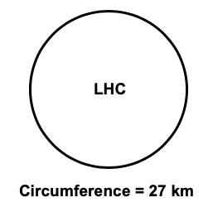

There are 9593 magnets in the LHC - varying from single dipoles, quadrupoles, sextupoles, octupoles, decapoles, etc. The strongest magnets consist of 1232 dipoles.

The dipoles are essentially used to guide the trajectory of the beams around the accelerators. The ‘insertion’ quadrupoles are special magnets used to ‘squeeze’ the proton beams and focus them to a size that is so small that the probability of proton collisions is enhanced greatly.

The peak dipole magnetic field strength reaches 7.74 T in the LHC. At a temperature of 1.9 K, the super conducting magnets can carry a current of 11850 A, which allows a maximum magnetic field strength of 8.33 T. This temperature is critical to guide the proton beam around the 27 km circumference LHC at an energy of 6.5 TeV without colliding with the sides of the vacuum tubes. At 4.5 K, the magnets could only carry a current of 8500 A and produce a magnetic field strength in the order of 6 T.

**HOW DO WE ‘SEE’ THE PARTICLES PRODUCED BY THE PROTON COLLISIONS?**

For each proton collision, the particle physicist’s goal is to count, track and characterise all the other different particles produced in order to reconstruct the collisions process as fully as possible. If the track of a particle can be traced, much valuable information can be discerned about that particle - particularly if the collision takes place in a magnetic field. Characteristics such as charge and momentum can be calculated. Very high momentum particles travel in almost straight lines; very low momentum particles make tighter spirals.

(a) Explain why the H atoms need to be ionised (i.e. protons created) for the operation of the LHC.

(2 marks)

The diagram below shows the structure of the particle accelerators in LINAC 1 and LINAC 2. It consists of ‘drift tubes’ (where the protons maintain a constant velocity) and ‘gaps’ between the tubes where the proton acceleration takes place. The proton acceleration occurs due to an alternating electric potential difference between each drift tube.

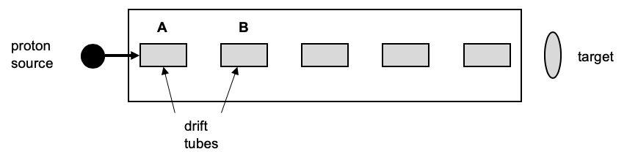

(b) On the two drift tubes that are indicated with arrows (A and B), draw two symbols (+ and -) to represent the electric potential required to accelerate the proton in the gap between them.

(1 mark)

(c) “At these energies, the protons are travelling so quickly that they circumnavigate the 27 km long LHC 11000 times per second.”

Use this information to calculate the speed of the protons as they travel around the LHC.

(3 marks)

(d) When the protons leave the two (2) linear accelerators (LINAC 1 and LINAC 2), they have achieved an energy of 50 MeV. Use this information to calculate the speed of the protons as they leave LINAC 2, given that relativistic effects can be ignored. (3 marks)

(e) Explain why changing the temperature of the super conductors (e.g. increasing to 4.5 K) will cause protons to collide with the vacuum tubes in the LHC. Include any mathematical expressions that will assist your answer. (4 marks)

The diagram below shows the tracks of two particles (A and B) in a detector.

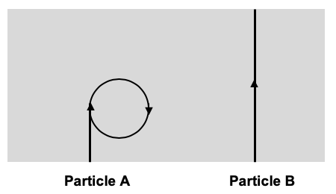

Both particles have the same sized positive charge.

(f) Use information in the article to describe each particle as either 'very high momentum' or 'very low momentum'. In the space below the table, explain why the path of Particle ‘B’ is virtually straight despite its positive charge. (3 marks)

|  |  |
| --- | --- |
| **Particle ‘A’** |  |
| **Particle ‘B’** |  |

On the diagram above, indicate the direction of the magnetic field that would cause the path of Particle ‘A’ to curve in the manner shown. (1 mark)

**END OF EXAM**

**EXTRA GRID**



**ADDITIONAL WORKING SPACE**

**ADDITIONAL WORKING SPACE**